FOR IMMEDIATE RELEASE

**For Pictures and more information**

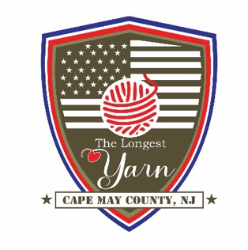**Contact:** Mark Kulkowitz

**Phone:** (609)602-6064

**Email:** [KulkowitzMark@yahoo.com](mailto:KulkowitzMark@yahoo.com)

**THE LONGEST YARN FUNDRAISER**

**Honoring The Greatest Generation**

Drop by the Cricket Club any time between 1:00 and 5:00 p.m. on April 7, 2024 to commemorate this anniversary and help fund this project. The afternoon will feature a Cricket Club-style buffet with complementary beer and wine, open seating, a silent auction, and a tribute to Cape May County’s own D-Day heroes. Tickets are $100 and can be purchased by contacting Kyle Kulkowitz at the Cricket Club (609)888-6095 or by email at kkulkowitz@gmail.com.

The 80th anniversary of D-Day is particularly important to the family of Cape May’s Carroll Villa, Mad Batter, and Cricket Club. Their founder and patriarch, Harry Kulkowitz was a member of the forces that landed on Utah Beach on June 6, 1944.

Cape May County artists have joined their international partners in creating multitudes of poppies in red, yellow, and purple for cascades which will adorn buildings in Caretan and Sainte Mere Eglise. The tapestry will be unveiled at Notre Dame Church in Caretan, France on May 28, 2024 and will remain on display until September. The tapestry will tour throught Europe and then come to the United States for display here in Cape May County at the Naval Air Station Wildwood Aviation Museum.

The Longest Yarn is a three-dimensional wool tapestry, knitted and crocheted by thousands of volunteers worldwide. It measures 80 meters (265 feet) and represents the 80 years since D-Day and the 80 days it took for the the allies to liberate Paris. The Longest Yarn tells the momentous story of June 6, from the build-up and launch in England through the Normandy invasion.